FOCUS


WINTER 2025

Sight Support and Social Hub
Thomas Herd House
10-12 Ward Road
Dundee DD1 1LX

Telephone: 01382 227101
E-mail: office@sshub.org.uk
Website: www.ssshub.org.uk

LAURA’S LETTER

Hello everyone,

Well, it is time for our Winter Focus once again, that came around quickly!!

Yet again we have had a busy few months in the Hub, and it has been a hive of activity as the team and our Members get ready for the Christmas Show. The building has been full of music from the dancers and choir, which has been lovely to hear!

Following our AGM on 23rd October, we are pleased to announce the appointment of new leadership within our Board of Directors. Keith Thomson has been elected as our new President and Mary Robertson will serve as Vice President.
Please join us in congratulating Keith and Mary on their new roles!

Please remember that ALL Members are welcome to come along to the Society, especially during the colder winter months – even if you do not wish to take part in activities just come down for a cuppy and a chat in a nice warm environment, and we may even be able to tempt you to stay for a home-cooked lunch!

Talking of food, we are also gearing up for our Christmas Lunches, which we are holding on the 9th & 11th December. These lunches are open to all Members, but we do need you to book and there is further information later in the Focus.

Our Christmas Raffle is starting to accumulate fantastic prizes, and we would like to thank our Members and their families for all the raffle donations we have received so far. The raffle tickets are available from reception or any of the team and are only £2.00.

I would like to say a heartfelt thank you to all our Members for their continued support during this year and to my amazing team – Ainslay, Jenni, Helen and Nicky, as well as our two volunteers Jackie and Lorna, for working so hard to help us deliver our activities and support to our Members week in and week out – they are an invaluable team!

So that leaves me with just wishing you all a very Merry Christmas and we hope to see more of you in the New Year!

Best Wishes
Laura

Sight Support & Social Hub Presents ‘‘Unseen Magic – A Christmas Celebration’’!

Our Social Activities team have been very busy organising the Christmas Show which will take place on Friday 5th December from 12pm.

The Line Dancers, Drum Fit and Seated Dancers have been practicing for months, and the choir now sound like the angels!

Everyone’s welcome and we hope you can come along and join in the fun! Entry is £5 and that includes a festive light buffet and mince pies washed down with refreshments. The fun starts at 12 noon on Friday 5th December – If you’d like a ticket they are available from our reception, or you can call the office on 01382 227101!





CHRISTMAS LUNCHES
Tuesday 9th December (number dependant)
&
Thursday 11th December
12pm-3pm


(Photo of Christmas dinner)
Melon or Soup
ba
Turkey, Gammon or Steak pie
with all the trimmings
ba
Strawberry Bauble Cake
or Triple Chocolate Gateau
ba
Tea/coffee and mince pies
followed by
A wee sing and ceilidh
£15.00
** Must be pre-booked, please call us to book your place
Christmas Hamper Raffle
We are so pleased to be able to hold our Christmas Hamper Raffle again this year!!

Our hamper donations are building up so for the price of a £2 raffle ticket you could end up with a fantastic hamper filled with delicious food, wine and lots of other goodies. Just ask any staff member or give us a ring to buy tickets, remember, you need to be in it to win it!



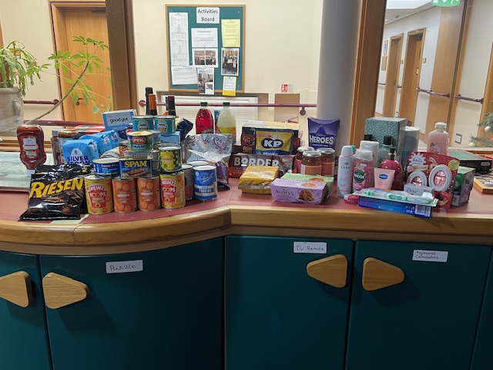

Congratulations to Our Lucky Winners!

We’re thrilled to announce that two of our members have won signed copies of Julia Donaldson books — a delightful prize from one of the UK’s most beloved children’s authors!
June Costello and Eddie Piper were the lucky recipients, and we couldn’t be happier for them.
These signed editions are a true treasure, and we hope they bring joy, inspiration, and a touch of literary magic.

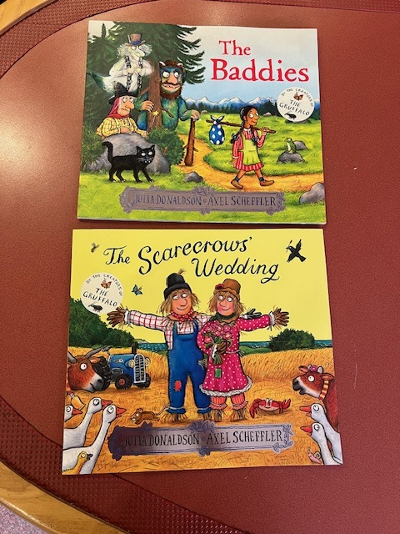

Guest Speakers

We were delighted to welcome representatives from Dundee Volunteer and Voluntary Action (DVVA) to the Sight Support and Social Hub.
During their visit, DVVA staff spoke about the wide range of services they offer — including Community Companions, which matches volunteers with individuals seeking friendship and social connection. They also spoke about Dial-OP, a phone-based support service offering daily check-ins, friendly chats, and helpful information.
For members who have access to the internet DVVA also introduced their Padlet which is an online, digital noticeboard. It serves as a central resource for finding information on social activities, community groups and support services available across Dundee and is free to use. If you’d like to take a look at what’s on offer you can find it at DVVA Social Inclusion Padlet
Our members also had the chance to ask questions, share their experiences, and learn how these services could support their wellbeing and independence. The conversation was lively, informative, and full of positive energy.
We’re grateful to DVVA for taking the time to connect with our community and for the valuable resources they continue to provide across Dundee.

Equality & Diversity Talk with Board Member Kenneth
We were excited to welcome Kenneth, one of our dedicated Board members, to the Sight Support and Social Hub for an inspiring talk on Equality and Diversity.
Kenneth led an open and engaging discussion with our members, exploring the importance of inclusion, respect, and understanding across all aspects of life. His talk touched on:
- The value of diverse perspectives in building stronger communities
- How equality impacts access to services, opportunities, and representation
- Practical ways we can all contribute to a more inclusive environment
Members had the chance to share their own experiences, ask questions, and reflect on how these principles shape our everyday interactions.
Kenneth’s visit was a powerful reminder that fostering equality and celebrating diversity is everyone’s responsibility — and that small actions can lead to meaningful change.
Thank you, Kenneth, for your time, insight, and commitment to making our community more inclusive.



Afternoon Tea & Tunes – A Delightful November Gathering
On 21st November, the Sight Support and Social Hub was filled with warmth, laughter, and the sweet sounds of ukulele music as we hosted a special Afternoon Tea for our members.
Guests enjoyed a delicious spread of cakes, sandwiches, and hot drinks — all served with a generous helping of good company and conversation. The highlight of the afternoon was a lively performance by Dee Ukes, whose upbeat tunes and singalong favourites had everyone smiling, clapping, and even dancing in their seats!
Their music brought a joyful energy to the room and created a truly memorable experience for all who attended.
For those who weren’t able to join us this time — don’t worry! You’ll be invited to our next Afternoon Tea on Friday 6th March 2026, and we can’t wait to welcome you then for another afternoon of treats, tunes, and togetherness.

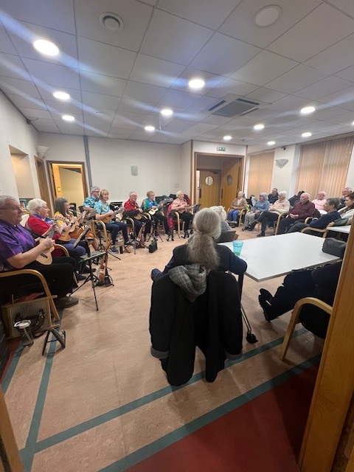

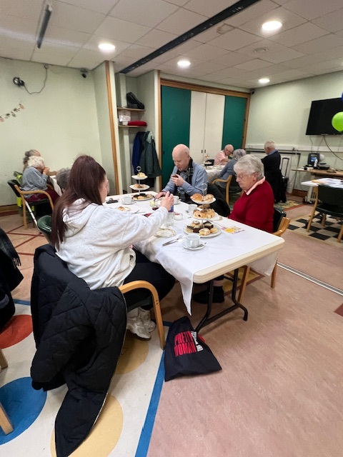
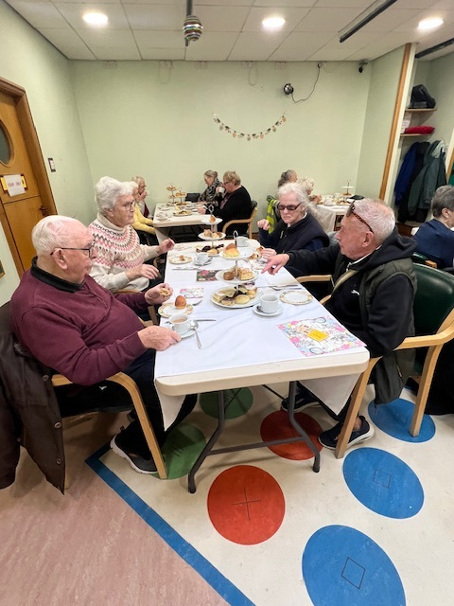

Laura Champions Inclusive Art on That’s TV Tayside
We’re proud to share that Laura, our Service Manager, recently appeared on That’s TV Tayside to speak about the importance of making art spaces more accessible for people who are blind or visually impaired.
In her insightful interview, Laura highlighted how creative venues can take meaningful steps toward inclusion, such as:
- Offering tactile exhibits and multi-sensory experiences
- Providing audio-described tours and accessible materials
- Using Braille signage and large-print guides
- Host inclusive workshops that welcome all abilities
Laura’s message was clear: “art should be for everyone, and with thoughtful adjustments, galleries, museums, and studios can open their doors wider to the visually impaired community.”
If you wish to review the video I have attached the link below.
https://www.facebook.com/share/v/1FBdjGdrfN/?mibextid=wwXIfr

Spooky Fun at the Sight Support and Social Hub Halloween Party!
Our Halloween Party at the Sight Support and Social Hub was a frightfully fun afternoon filled with laughter, games, and plenty of spooky spirit!
Members got into the Halloween mood with classic party games, including:
- Stick the Nose on the Witch — a playful twist on the traditional party game that had everyone guessing and giggling as they tried to find the right spot!
- Ball Darts — a lively challenge that brought out some friendly competition and lots of cheering as members aimed for the target.
The hub was decorated with Halloween flair, and the atmosphere was full of joy and camaraderie. It was wonderful to see everyone enjoying themselves, sharing laughs, and celebrating together.
Thank you to all who joined us — and to our amazing staff and volunteers who made the day so special. We’re already looking forward to next year’s spooky celebration!

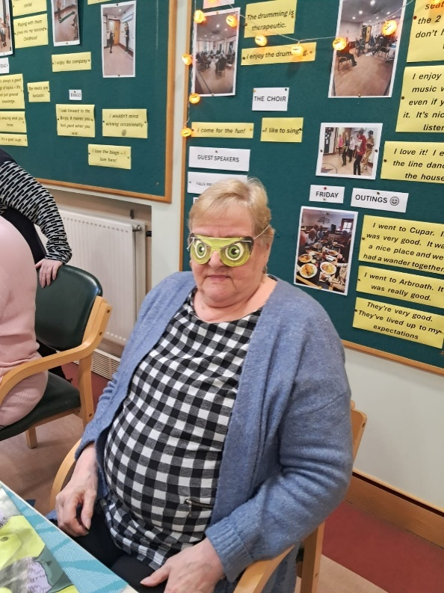
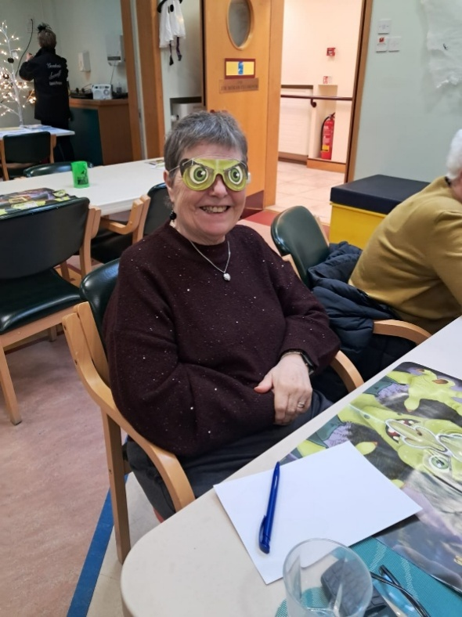
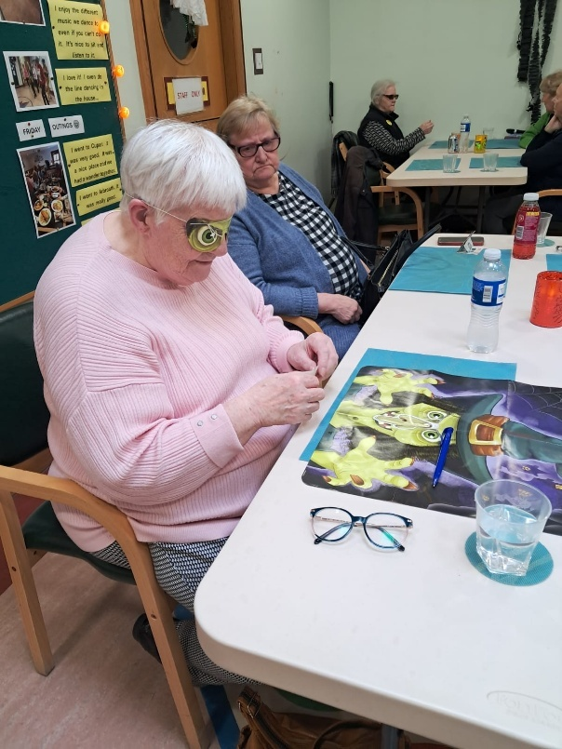
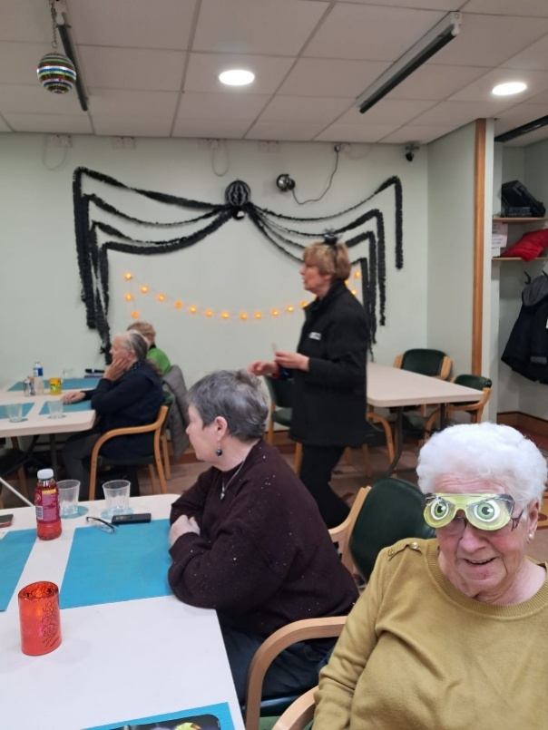

🚌 A Year of Adventures — Thank You for Joining Us!
As 2025 draws to a close, we’re reflecting on the fantastic outings we’ve shared with our members — and what a roaring success they’ve been!
From scenic lunches to cultural discoveries, our trips have brought joy, connection, and plenty of great memories. This year, we visited:
- Bell Tree, Bayview, and Bridgeview Station — where members enjoyed delicious meals and beautiful views
- The Transport Museum and Bellrock — sparking curiosity and conversation around Dundee’s rich history
- The Jam Factory and Stewarts in St Andrews — visited multiple times with
different groups, each outing filled with laughter and sweet treats
- Taypark — a relaxing stop with lovely surroundings
- And most recently, Dundee College, where members explored new flavours and textures.
Each trip has been met with enthusiasm, smiles, and a wonderful sense of togetherness. We’ve loved seeing our members engage, connect, and make the most of these experiences.
A huge thank you to everyone who joined us — your energy and participation made these outings truly special. We can’t wait to plan more adventures in the year ahead!
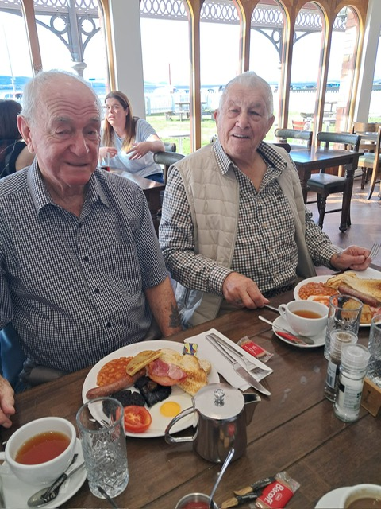
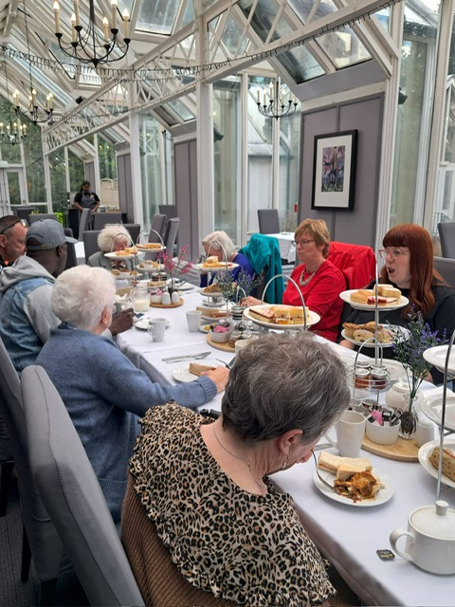

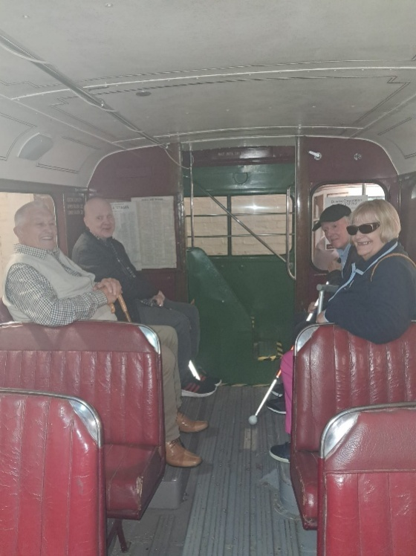
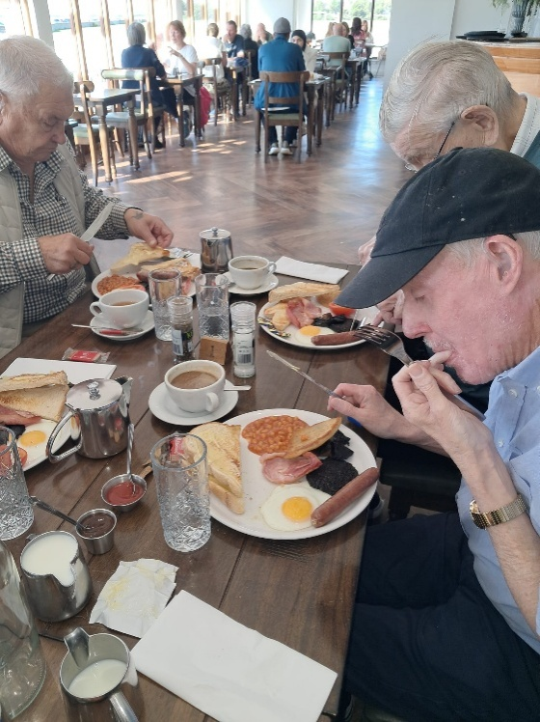

A Blooming Thank You to Sheila and Eddie Piper!

We’d like to extend our heartfelt thanks to Sheila Piper for her generous donation of beautiful flowers to our sensory garden. Her thoughtful gift has added vibrant colour and a touch of serenity to a space cherished by so many in our Social Hub.

A special thank you also goes to her husband, Eddie, whose ongoing care and attention ensures the garden continues to flourish. His dedication keeps the blooms thriving and the space welcoming for all who visit.

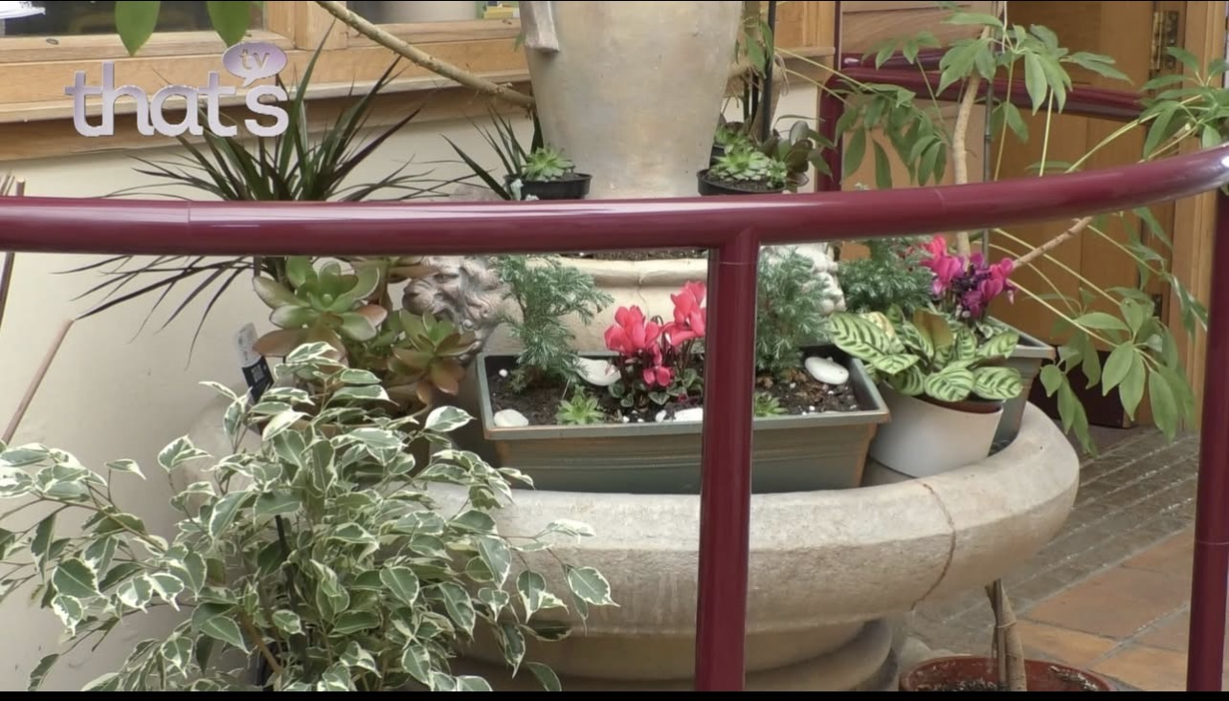

NESS DROP-INS

NESS will continue to pop into the social hub to provide advice and support. They will be here between 11:00am and 12:00pm, so, if you have any questions about equipment available or just a general question please come along on the following dates:

Thursday 29th Jan (Kevin, ICT – Accessible Technology)

Wednesday 25th Feb (Margaret - Social work/Benefit Support)

Wednesday 25th March (Audrey, Equipment Assistance)

Wednesday 29th April (Social Work/General Advice)

Winter Holidays

Please note:

The staff will be on annual leave for the period;

12pm, Thursday 18th December
To
9am, Monday 5th January

We will be back in the office on Monday 5th January 2025. This may seem like a long break, but it is one of the only opportunities in the year when we can all have a break at the same time.

If you have an emergency over the Christmas period please contact;

438300 (Social Work Department)
307964 (Out Of Hours Team – only
contactable evening and public
holidays)

“A very Merry Christmas to one and all from everyone at the Social Hub”

CROSSWORD

1 |  | 2 |  | 3 |  | 4 |  |  | 5 | 6 |  | 7
 |  |  |  |  |  |  |  | 8
 |  |  |  | 9
10 | 11 |  |  |  |  |  |  | 12
13 |  | 14 |  |  | 15
 |  |  |  | 16
17 |  | 18 |  |  |  | 19 |  |  | 20 |  | 21
 |  |  |  |  |  |  |  | 22
23 |  |  |  |  |  |  |  | 24 |  | 25 |  | 26
 |  |  |  | 27
28 |  |  |  |  | 29
CLUES ACROSS
1 – READING OF A REGISTER (4,4)
5 – GIVE OVER (4)
9 – INTIMIDATE (5)
10 – GARDEN ORNAMENT (5)
12 – DRIVEL (5)
13 – SWING TO AND FRO (4)
15 – BODY OF WATER BETWEEN AFRICA
AND YEMEN (3,3)
18 – BASKETWORK FIBRE (6)
20 – EAGER (4)
23 – OFFENCE PUNISHABLE BY LAW (5)
24 – BURNING (5)
20 – CLEAN AND AN ABRASIVE (5)
28 – RAGGED (4)
29 – SHAKY, INFIRM (8)

CLUES DOWN
1 – JEWELLERY ITEM (4)
2 – FLOOR COVERING (4)
3 – DRINK MADE FROM APPLES (5)
4 – HUGH ……, COMEDY ACTOR (6)
6 – CALCULATE ROUGHLY (8)
7 – NOT INCLUDING (6)
8 – CERTIFY (6)
11 – UNUSED (3)
15 – AMULET (8)
14 – PASSENGER PLANE (6)
16 – AGAIN (6)
17 – PAIL (6)
19 – HEREDITARY (6)
21 – ORGAN WITH A DRUM (3)
22 – GOLD PURITY STANDARD (5)
25 – US STATE, CAPITAL DES MONIES (4)
26 – CATCH SIGHT OF (4)

WORD SEARCH

S | I | W | L | M | I | S | W | N | E | R | F
H | R | N | R | D | J | G | G | X | A | M | F
D | L | C | A | S | I | E | E | N | A | B | P
R | O | Y | H | R | N | R | S | I | I | M | I
E | S | W | T | R | A | H | L | U | A | K | W
I | S | O | N | L | I | L | O | G | S | O | E
M | N | U | C | I | I | S | D | J | L | S | P
E | T | N | O | W | N | A | T | F | T | E | A
Y | O | R | Z | H | L | G | S | S | M | S | D
Z | G | T | I | E | R | O | I | B | W | A | U
S | I | D | N | N | N | E | R | W | R | I | E
F | R | E | O | T | I | O | T | W | V | U | T
I | S | T | L | N | K | T | I | E | G | S | T
N | Y | W | L | E | S | N | Y | O | P | I | O

WORD SEARCH – CAMBRIDGE COLLEGE, THE LIGHT BLUES

CHRIST’S MAGDALENE
CLARE PEMBROKE
DARWIN PETERHOUSE
DOWNING SELWYN
FITZWILLIAM ST JOHN’S
GIRTON TRINITY
JESUS WOLFSON
KING’S

So-Duko

9 |  |  |  |  | 6 |  | 2
 |  | 5 |  | 2 |  |  | 8
 |  |  |  | 3 | 5 |  |  | 9
 |  | 8 | 5 | 6
 |  |  |  |  | 4 |  | 5
 | 7 | 6 | 9 |  | 8
 |  |  |  | 5 | 3 |  | 1
 |  | 7 | 4 |  |  | 9
 | 3 |  |  |  |  | 2

CROSSWORD SOLUTION

R | O | L | L | C | A | L | L |  | C | E | D | E
I |  | I |  | I |  | A |  | A |  | S |  | X
N |  | N |  | D | A | U | N | T |  | T |  | C
G | N | O | M | E |  | R |  | T | R | I | P | E
 | E |  |  | R |  | I |  | E |  | M |  | P
S | W | A | Y |  | R | E | D | S | E | A |  | T
 |  | I |  | A |  |  |  | T |  | T
B |  | R | A | F | F | I | A |  | K | E | E | N
U |  | L |  | R |  | N |  | C |  |  | A
C | R | I | M | E |  | B |  | A | F | I | R | E
K |  | N |  | S | C | O | U | R |  | O |  | S
E |  | E |  | H |  | R |  | A |  | W |  | P
T | O | R | N |  | U | N | S | T | E | A | D | Y
So-Duko

9 | 8 | 3 | 7 | 4 | 6 | 5 | 2 | 1
7 | 6 | 5 | 1 | 2 | 9 | 3 | 8 | 4
4 | 1 | 2 | 8 | 3 | 5 | 6 | 7 | 9
3 | 4 | 8 | 5 | 6 | 2 | 1 | 9 | 7
1 | 2 | 9 | 3 | 7 | 4 | 8 | 5 | 6
5 | 7 | 6 | 9 | 1 | 8 | 4 | 3 | 2
6 | 9 | 4 | 2 | 5 | 3 | 7 | 1 | 8
2 | 5 | 7 | 4 | 8 | 1 | 9 | 6 | 3
8 | 3 | 1 | 6 | 9 | 7 | 2 | 4 | 5

Activity Timetable

Monday
Boccia/Quiz/  Chat | £10 | 11.00 |  | 12.15
2 Course Lunch –followed by chat | £10 | 12.15 |  | 14.50
Tuesday
Games Morning | £10 | 11.00 |  | 12.15
2 Course Lunch | £10 | 12.15 |  | 13.15
Bingo | 1 Book £4.00 | 13.15 |  | 14.50
 | 2 Books £6.50
 | 3 Books £8.00
 | *Tea/Coffee can be purchased for £1.50
Wednesday
Fun Drum | £10 | 11.00 |  | 12.15
2 Course Lunch | £10 | 12.15 |  | 1315
Choir | £10 | 13.15 |  | 14.50
Thursday
Line Dancing | £10 | 11.00 |  | 12.15
2 Course Lunch | £10 | 12.15 |  | 13.15
Bingo | 1 Book £4.00 | 13.15 |  | 14.50
 | 2 Books £6.50
 | 3 Books £8.00
 | *Tea/Coffee can be purchased for £1.50
Friday***
Armchair Aerobics/Dancing | £10 | 11.00 |  | 12.15
2 Course Lunch followed by chat | £10 | 12.15 |  | 13.45



