FOCUS


SPRING 2026
Sight Support and Social Hub
Thomas Herd House
10-12 Ward Road
Dundee DD1 1LX

Telephone: 01382 227101
E-mail: office@sshub.org.uk
Website: www.ssshub.org.uk

LAURA’S LETTER

Hello everyone,

Firstly, I want to say a heartfelt thank you for all the Christmas gifts we received from our members. We were genuinely touched by your kindness and generosity. Your thoughtfulness means a great deal to us, and every gift was very much appreciated (and enjoyed!).

I would also like to extend our sincere thanks to everyone who donated to the Social Hub. We know that the cost of living has risen sharply, and receiving donations at this time is incredibly humbling. Your support helps us continue the work we do, and we are truly grateful.

We also had the pleasure of hosting our Christmas show, Unseen Magic, which was very well attended. The performances from our members were fantastic — full of confidence, creativity, and festive spirit. It was wonderful to see so many people come along to support the show, and we are incredibly proud of everyone who took part.

Christmas overall was a busy and joyful time here, with two very well attended festive lunches. Our cook, Nicky, rose to the challenge of preparing a full three course meal and made it look effortless. The food was delicious, and we are so thankful to her for bringing such skill and warmth to the kitchen. If you haven’t yet tried one of Nicky’s lunches, you really are missing out — just give us a call and we’ll be delighted to book you in.
As we look ahead to another busy year at the Society, we would love to welcome more of you through the door.

Why not come along and try an activity? You might discover something new that you really enjoy.

We hope to see you soon.

Best Wishes
Laura

Sight Support & Social Hub Presents ‘‘Unseen Magic – A Christmas Celebration’’!

Wow, just wow! What an amazing Christmas show we had.

For most of the year all our dancers, drummers and singers had been practicing hard to show their friends and loved ones what we get up to here in the hub, and I am very pleased to say they weren’t disappointed.

It was a true testament to the hard work that was put in by Ainsley and the team to present an absolute treasure of a show, that was enjoyed by all. The show included a solo by Paul and a special dance choreographed by Sandra, who are both members.

If you would like to be part of the fun next year, come along and have a go at the line dancing, seated dancing, singing or drumming, there’s plenty to choose from.

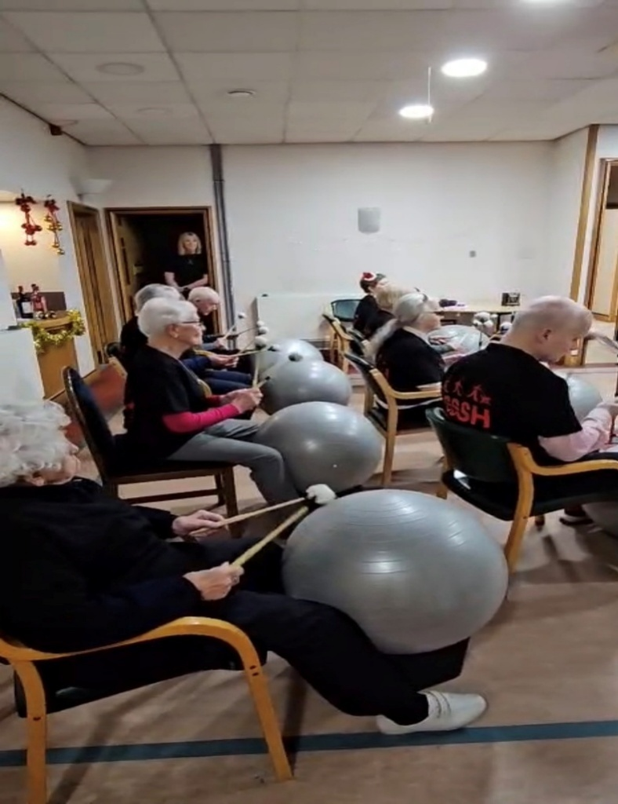

Christmas Lunches

It seems a little while ago now that we were all sat around the table enjoying our annual Christmas lunches here in the Hub, all expertly prepared by our own lovely Nicky, and I might add, very tasty too.

Prior to his extremely busy night on Christmas Eve, Santa even managed to pay us a visit too and give out selection boxes to our members. A huge thank you to Santa for taking the time out of his busy schedule to pay us a visit.

Christmas Hamper Raffle

During the Christmas Show we took the opportunity to draw the raffle for the hampers. The following lucky people were winners:

Large Hamper – Chic Hodge
Medium Hamper – Audrey Mooney
Small Hamper – Eddie Moir
Care Package – Libby Elliot
£25 Tesco Voucher – Sheila Campbell
£10 Overgate Voucher – Libby Elliot
£10 Overgate Voucher – Paul Chalmers

Congratulations to all the winners!!

We are delighted to have raised £228.00 for the Social Hub!!!


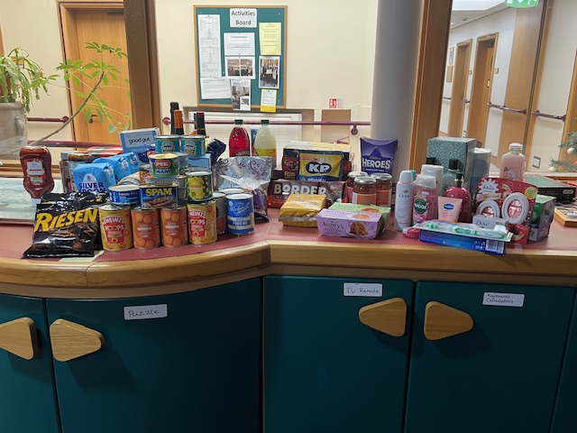

Clocks Spring Forward!



A little reminder that clocks all move forward one hour on Sunday 29th March. If anyone needs any assistance with clock changes then please let us know.

A Heartfelt Thank You

We would also like to extend our heartfelt thanks to Sheila Terry’s family for their generous donation of audiobooks. Their kindness means a great deal to us, and these audiobooks will be enjoyed by many. We are truly grateful for their support and thoughtfulness.
Sensory Art Encounter with the DCA

The recent visit from the DCA offered our members a rare and meaningful opportunity to engage directly with the materials used in the DCA’s latest exhibition. We contain Multitudes featuring work by Andrew Gannon, Nnena Kalu (Turner Prize Winner 2026), Daisy Lafarge and Jo Longhurst.

The team brought along a selection of the original textures, objects, and creative elements featured in their work, inviting our members to touch, explore, and respond to them in their own ways. This hands-on session not only deepened everyone’s connection to the artists process but also opened thoughtful conversations about how different people interpret and experience artistic materials through sensory engagement.

For more information about the exhibition please visit https://www.dca.org.uk/events/o3w-we-contain-multitudes/.

The exhibition is located in the galleries and runs until Sunday 26th April 2026

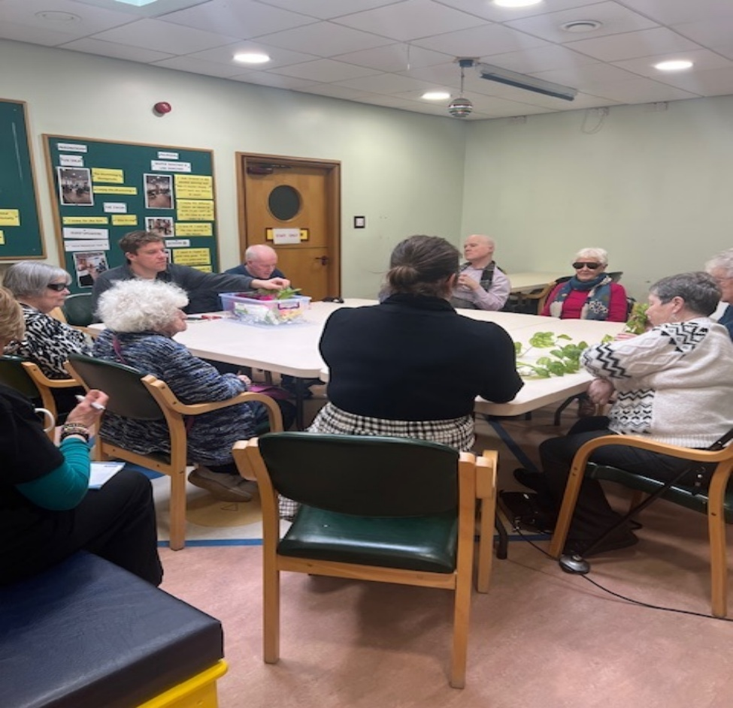

Easter Chocolate Hamper Raffle

It’s time for our Easter Chocolate Hamper Raffle again!
Tickets are priced £2 available from reception or any of the team.

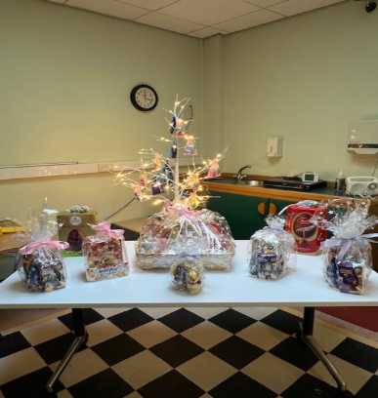

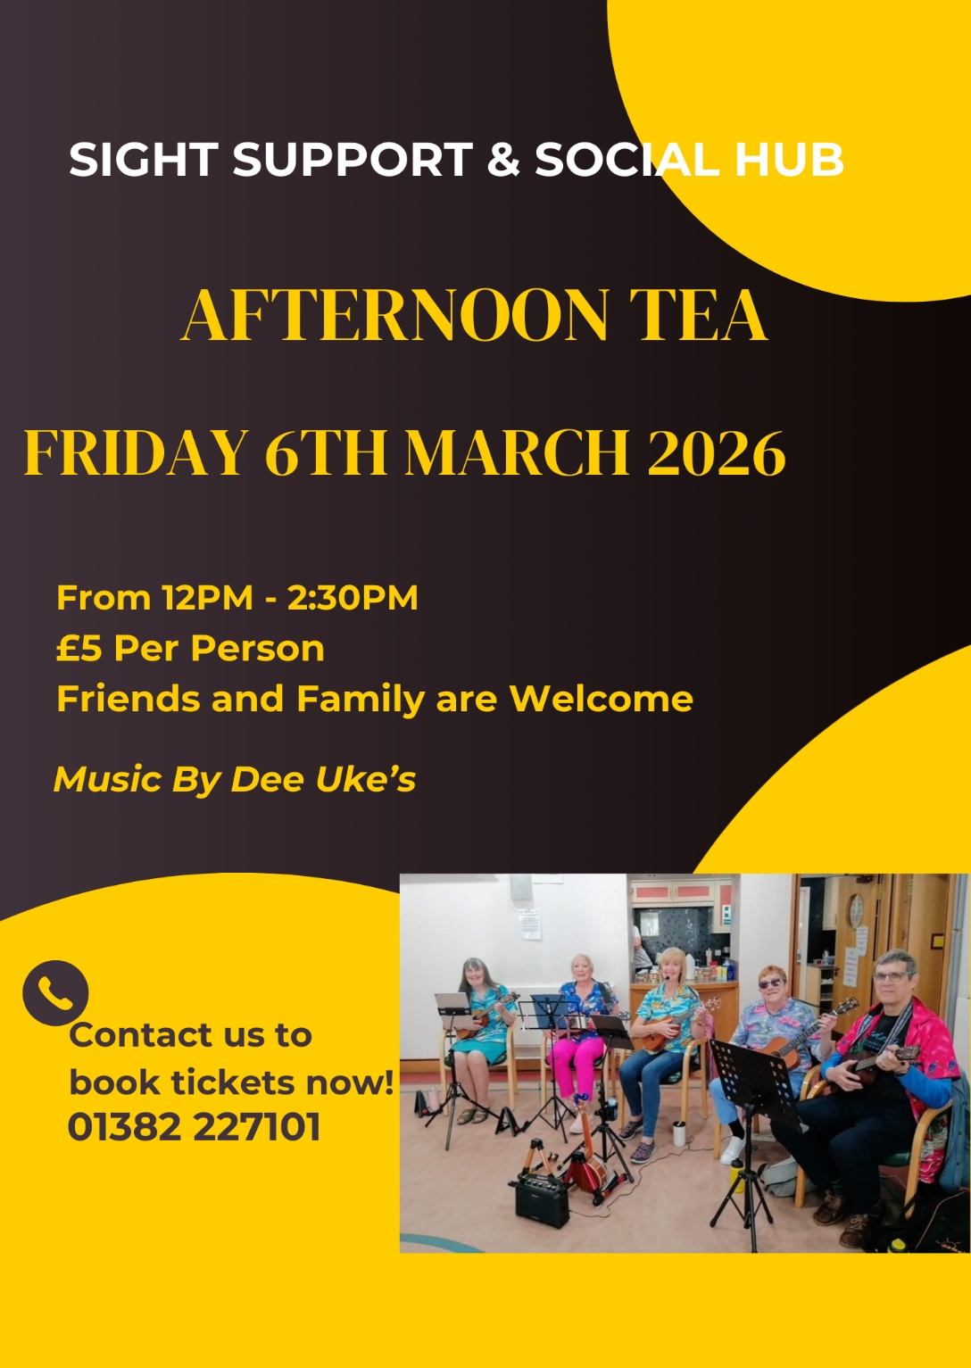
Afternoon Tea & Tunes – 6th March 2026

Friday Outings Are Back – And We’d Love Your Ideas.

We’re delighted to share that our Friday Outings will be returning over the coming months. These trips have always been a highlight for many of you, offering a chance to explore, relax, and enjoy time together — and we can’t wait to get going again.
Each outing costs £15 per person, and we’re always keen to hear your suggestions. If there’s somewhere you’d love to visit, please let us know. Your ideas help us plan days out that everyone can enjoy.

To give you a flavour of what’s ahead, here’s a look at our upcoming plans:

Upcoming Friday Outings
- Friday 13th March 2026 – Afternoon Tea at Dundee & Angus College.
- Friday 20th March – A visit to Stewarts Resort, St Andrews.
- Friday 27th March – Afternoon Tea at Dundee & Angus College.
- Friday 3rd April – Trip to Caulders Garden Centre, Cupar.
- Friday 24th April – Lunch at The Bellrock Restaurant, Arbroath.
- Friday 1st May – Visit to The Black Watch Museum, including lunch, £20. This one costs a little more than the others because it covers the museum’s admission fee.

- Friday 8th May 2026 – The Bell Tree

We’ve also included some photos from our previous adventures below — a lovely reminder of the fun we’ve shared and a taste of what’s still to come.

Please contact reception on 227101 to reserve your place as spaces are offered on a first come, first served basis.
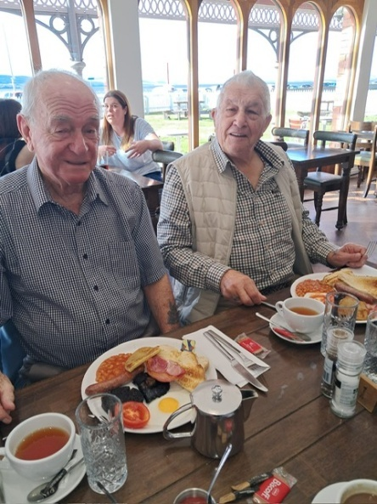
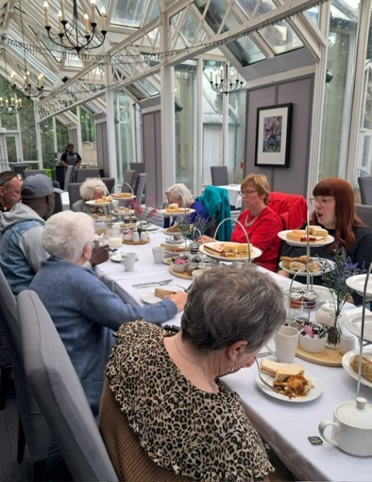


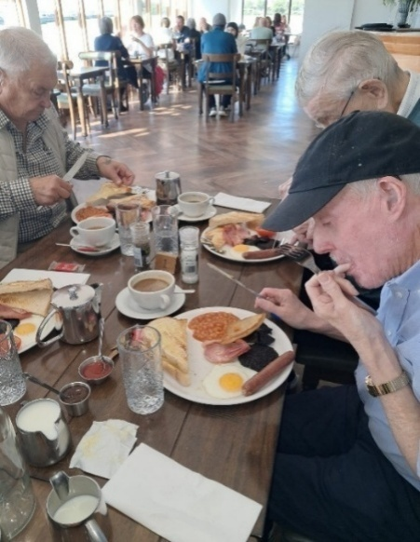



Sight loss counselling

RNIB’s Counselling team offers emotional support for those with sight loss
RNIB offers emotional support for blind and partially sighted people through our Sight Loss Counselling team, a group of professional telephone and online counsellors.

Our service is accredited by the British Association for Counselling and Psychotherapy (BACP) and is completely confidential.

We are bound by the BACP ethical framework for the Counselling Professions. We also comply with the Data Protection Act.

- One-to-one telephone counselling – this gives you the time and support to talk through your situation and feelings
- Online counselling – use the self-refer form to get in touch with our team through email, video or instant messaging
- Telephone support groups – discuss your feelings and experiences in small groups facilitated by one of our counsellors
- Guides to good mental health – we've produced a series of guides with tips on improving your mental wellbeing.

How to contact the Sight Loss Counselling team,

Get in touch with our friendly team through the Helpline today if you or someone you care for needs help call us on 0303 123 9999 from Monday to Friday 8am to 8pm, and Saturday 9am to 1pm or emails us at helpline@rnib.org.uk. You can also get in touch with the counselling team directly by leaving us a message on 020 7391 2186 or emailing cwt@rnib.org.uk.

Upcoming Office Closure

Please note that the Sight Support & Social Hub office will be closed on the following dates due to staff training:
- Wednesday 4th March 2026
- Thursday 12th March 2026
- Monday 16th March 2026
- Monday 30th March 2026

We appreciate your understanding and apologise for any inconvenience this may cause.

NESS DROP-INS

NESS will continue to pop into the social hub to provide advice and support. They will be here between 11:00am and 12:00pm, so, if you have any questions about equipment available or just a general question please come along on the following dates:

Wednesday 25th Feb (Margaret - Social work/Benefit Support)

Wednesday 25th March (Audrey, Equipment Assistance)

Wednesday 29th April (Social Work/General Advice)
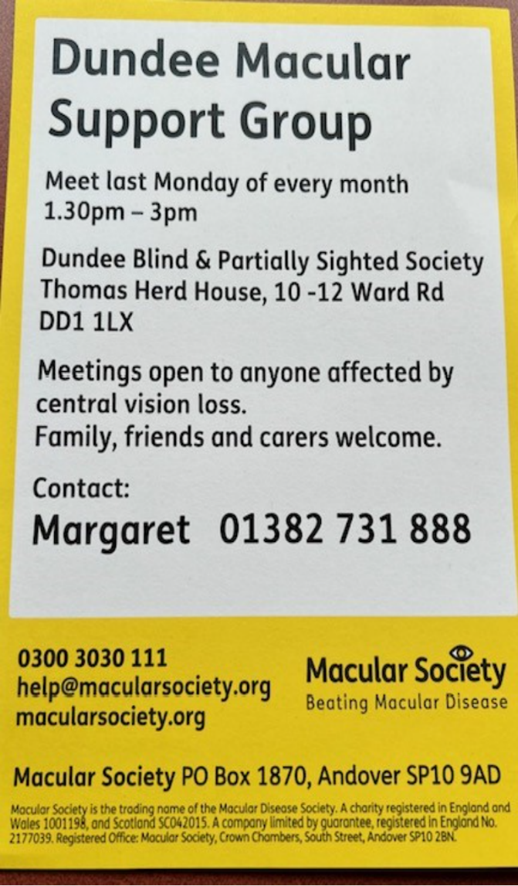

The date for the upcoming macular group meeting has been brought forward, and it will now take place on Monday, 23 March 2026.
Please update your plans accordingly so you don’t miss the session, and feel free to share this change with anyone else who may be attending.

CROSSWORD

1 |  | 2 |  |  | 3 |  | 4 |  |  | 5 |  | 6
7 |  |  | 8 |  |  |  |  |  | 9
 |  | 10 |  |  |  | 11
12 |  |  |  |  |  |  |  |  | 13
 |  |  | 14
15 |  |  |  |  |  |  |  |  | 16 |  |  | 17
 |  | 18 |  |  | 19 |  | 20 |  |  | 21
22 |  |  |  |  |  |  |  |  | 23
24 |  |  |  |  |  |  | 25
CLUES ACROSS
1 – SALAD FRUIT (6)
4 – CLERGYMAN IN CHARGE OF DIOCESE (6)
7 – CRICKETER, …. STEWART (4)
9 – UNSPECIFIED AMOUNT (4)
10 – IDEAS GROUP (5,4)
12 – DRAG, TUG (4)
13 – PAYMENT FOR SERVICES (4)
14 – FAIRGROUND CARS (7)
15 – ISLE OF MAN TOWN (4)
16 – NORSE (4)
18 – HYPOCRITICAL (9)
22 – SOLID SHAPE WITH SIX SIDES (4)
23 – STALLION’S PARTNER (4)
24 – COLIN ……, ENGLISH CRIME WRITER (6)
25 – KERNEL WITH A WRINKLED SHELL (6)

CLUES DOWN
1 – ITEM OF CROCKERY (6)
2 – ENCOUNTER (4)
3 – COOKING COMPARTMENT (4)
4 – URCHIN (4)
5 – POOR GOLF SHOT (4)
6 – POLITE WORD OF REQUEST (6)
8 – KID’S CHARITY (9)
9 – BLIZZARD (9)
11 – MOST IMPORTANT PERSON (7)
15 – CALM, PEACEFUL (6)
17 – MOST UNUSUAL (6)
18 – LARGE MOUNTAIN GOAT (4)
19 – CARTOON LOCOMOTIVE, …. THE ENGINE (4)
20 – SHIP’S COMPANY (4)
21 – MAKE MONEY (4)

WORD SEARCH

E | M | S | A | L | A | P | G | W | R | W | D
R | L | L | F | E | U | L | Z | Q | I | A | D
V | E | A | S | A | N | I | B | A | W | Y | S
W | B | X | D | K | E | N | T | A | A | N | M
E | I | M | A | R | A | L | D | I | N | E | Y
I | E | L | N | L | E | R | W | E | E | Y | R
A | L | N | L | E | A | D | E | N | K | E | R
W | L | D | L | I | M | I | U | Y | S | L | E
C | L | E | L | A | A | I | R | A | O | D | N
E | E | R | M | T | R | M | R | P | L | S | M
L | W | I | A | R | A | F | E | I | T | R | U
P | D | E | I | E | M | I | B | A | B | U | S
N | I | T | N | I | A | S | R | O | R | E | A
P | B | E | N | O | T | P | U | L | E | L | L

WORD SEARCH – FORTRESS

ALBANY LUPTON
BIDWELL MIRIBEL
ERIE PAYNE
FRASER SAINT
KENT SUMNER
LARAMIE WAYNE
LAUDERDALE WILLIAM
LIARD

So-Duko

1 |  | 5 | 6 |  |  |  | 3 | 7
 |  |  |  |  |  |  | 1
 | 2 |  |  | 7 | 5 |  | 8
 |  |  | 3 | 4 |  |  | 7
 | 1 |  | 8 |  |  |  | 2 | 9
8 |  |  |  |  |  | 6
6 | 5 |  |  | 8 |  | 7
 | 8 |  | 5 | 1
 | 9

CROSSWORD SOLUTION

T | O | M | A | T | O |  | B | I | S | H | O | P
E |  | E |  |  | V |  | R |  |  | O |  | L
A | L | E | C |  | E |  | A |  | S | O | M | E
C |  | T | H | I | N | K | T | A | N | K |  | A
U |  |  | I |  |  | I |  |  | O |  |  | S
P | U | L | L |  |  | N |  |  | W | A | G | E
 |  |  | D | O | D | G | E | M | S
P | E | E | L |  |  | P |  |  | T | H | O | R
L |  |  | I |  |  |  |  |  | O |  |  | A
A |  | I | N | S | I | N | C | E | R | E |  | R
C | U | B | E |  | V |  | R |  | M | A | R | E
I |  | E |  |  | O |  | E |  |  | R |  | S
D | E | X | T | E | R |  | W | A | L | N | U | T
So-Duko

1 | 4 | 5 | 6 | 9 | 8 | 2 | 3 | 7
9 | 7 | 8 | 4 | 2 | 3 | 5 | 1 | 6
3 | 2 | 6 | 1 | 7 | 5 | 9 | 8 | 4
2 | 6 | 9 | 3 | 4 | 1 | 8 | 7 | 5
5 | 1 | 4 | 8 | 6 | 7 | 3 | 2 | 9
8 | 3 | 7 | 9 | 5 | 2 | 6 | 4 | 1
6 | 5 | 1 | 2 | 8 | 4 | 7 | 9 | 3
7 | 8 | 3 | 5 | 1 | 9 | 4 | 6 | 2
4 | 9 | 2 | 7 | 3 | 6 | 1 | 5 | 8

Activity Timetable

Monday
Boccia/Quiz/  Chat | £10 | 11.00 |  | 12.15
2 Course Lunch –followed by chat | £10 | 12.15 |  | 14.50
Tuesday
Games Morning | £10 | 11.00 |  | 12.15
2 Course Lunch | £10 | 12.15 |  | 13.15
Bingo | 1 Book £4.00 | 13.15 |  | 14.50
 | 2 Books £6.50
 | 3 Books £8.00
 | *Tea/Coffee can be purchased for £1.50
Wednesday
Fun Drum | £10 | 11.00 |  | 12.15
2 Course Lunch | £10 | 12.15 |  | 1315
Choir | £10 | 13.15 |  | 14.50
Thursday
Line Dancing | £10 | 11.00 |  | 12.15
2 Course Lunch | £10 | 12.15 |  | 13.15
Bingo | 1 Book £4.00 | 13.15 |  | 14.50
 | 2 Books £6.50
 | 3 Books £8.00
 | *Tea/Coffee can be purchased for £1.50
Friday***
Armchair Aerobics/Dancing | £10 | 11.00 |  | 12.15
2 Course Lunch followed by chat | £10 | 12.15 |  | 13.45



